3EJ4 Formula Sheet

M0: Review of 2EI4

MOSFET DC/Large-Signal:
$V_{OV}=V_{GS}-V_{tn}=V_{SG}-\left|V_{tp}\right|$ $K=K'\left[\frac{W}{L}\right]=μ_{e}C_{ox}\left[\frac{W}{L}\right]$ [A/V²]
Region of Operation (NMOS) | Assume | Check
Cutoff | $$I_{DS}=0$$ | $$V_{GS}≤V_{tn}$$
Linear | $$I_{DS}=K_{n}\left[V_{OV}V_{DS}-\frac{{V_{DS}}^{2}}{2}\right]$$ | $$V_{GS}≥V_{tn}$$  $${0≤V}_{DS}≤V_{OV}$$
Saturation | $$I_{DS}=\frac{K_{n}}{2}{V_{OV}}^{2}(1+λV_{DS})$$ | $$V_{GS}≥V_{tn}$$  $$V_{DS}≥V_{OV}≥0$$
**For DC analysis, unless explicitly specified otherwise, assume CLM effect $λ=0$
**For PMOS, $V_{tp}<0.$ To prevent the sign conversion use $\left|V_{tp}\right|$.
Region of Operation (PMOS) | Assume | Check
Cutoff | $$I_{SD}=0$$ | $$V_{SG}≤\left|V_{tp}\right|$$
Linear | $$I_{SD}=K_{p}\left(V_{OV}V_{SD}-\frac{{V_{SD}}^{2}}{2}\right)$$ | $$V_{SG}≥\left|V_{tp}\right|$$  $${0≤V}_{SD}≤V_{OV}$$
Saturation | $$I_{SD}=\frac{K_{p}}{2}{V_{OV}}^{2}(1+λV_{SD})$$ | $$V_{SG}≥\left|V_{tp}\right|$$  $V_{SD}≥V_{OV}≥0$

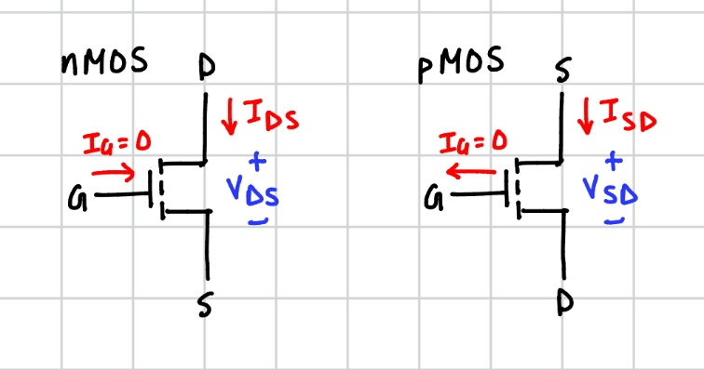

BJT DC/Large-Signal:
$V_{A}=\frac{1}{λ}$ $I_{E}=I_{B}+I_{C}$
Region of Operation (NPN) | Assume | Check
Cutoff | $$I_{B}=I_{C}=0$$ | $$V_{BE\left(on\right)}<0.7V$$  $$V_{BC(on)}<0.5V$$
Saturation | $$V_{BE\left(on\right)}=0.7V$$  $$V_{BC(on)}=0.5V$$ | $$I_{B},I_{C}>0$$  $$I_{C}≤βI_{B}$$
Active | $$V_{BE\left(on\right)}=0.7V$$  $$I_{C}=βI_{B}\left(1+\frac{V_{CE}}{V_{A}}\right)$$ | $$I_{B}>0$$  $$V_{CE}≥0.3V$$  $$V_{BC(on)}<0.5V$$
**For DC analysis, unless explicitly specified otherwise, assume $V_{A}=∞$
Region of Operation (PNP) | Assume | Check
Cutoff | $$I_{B}=I_{C}=0$$ | $$V_{EB\left(on\right)}<0.7V$$  $$V_{CB(on)}<0.5V$$
Saturation | $$V_{EB\left(on\right)}=0.7V$$  $$V_{CB(on)}=0.5V$$ | $$I_{B},I_{C}>0$$  $$I_{C}≤βI_{B}$$
Active | $$V_{EB\left(on\right)}=0.7V$$  $$I_{C}=βI_{B}\left(1+\frac{V_{EC}}{V_{A}}\right)$$ | $$I_{B}>0$$  $$V_{CE}≥0.3V$$  $$V_{CB(on)}<0.5V$$

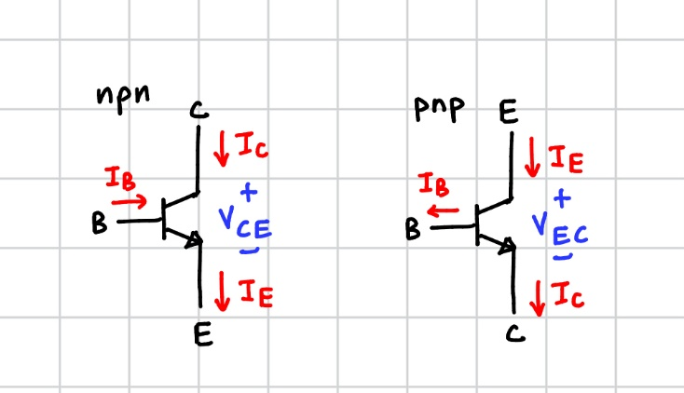

MOSFET Small Signal Model Parameters:
$g_{m}=\frac{2I_{DS}}{V_{OV}}=\sqrt{2KI_{D}(1+λV_{DS})}≈\sqrt{2KI_{D}} [S]$ $r_{o}=\frac{\left|\frac{1}{λ}+V_{DS}\right|}{I_{DS}} ≈\frac{1}{\left|λ\right|I_{DS}} ≈\frac{\left|V_{A}\right|}{I_{DS}}$ $r_{e}=\frac{1}{g_{m}}$

BJT Small Signal Model Parameters:
$g_{m}=\frac{I_{C}}{V_{T}}$ , $V_{T}=25mV$ $r_{π}=\frac{β}{g_{m}}$ $r_{e}=\frac{α}{g_{m}}=\frac{V_{T}}{I_{E}}$ $r_{o}=\frac{V_{A}}{I_{C}}$ $α=\frac{β}{β+1}$
$i_{c}=β∙i_{b}=α∙i_{e}$ $i_{e}=i_{b}+i_{c}=(β+1)i_{b}$

Small Signal Models:
$π$-model
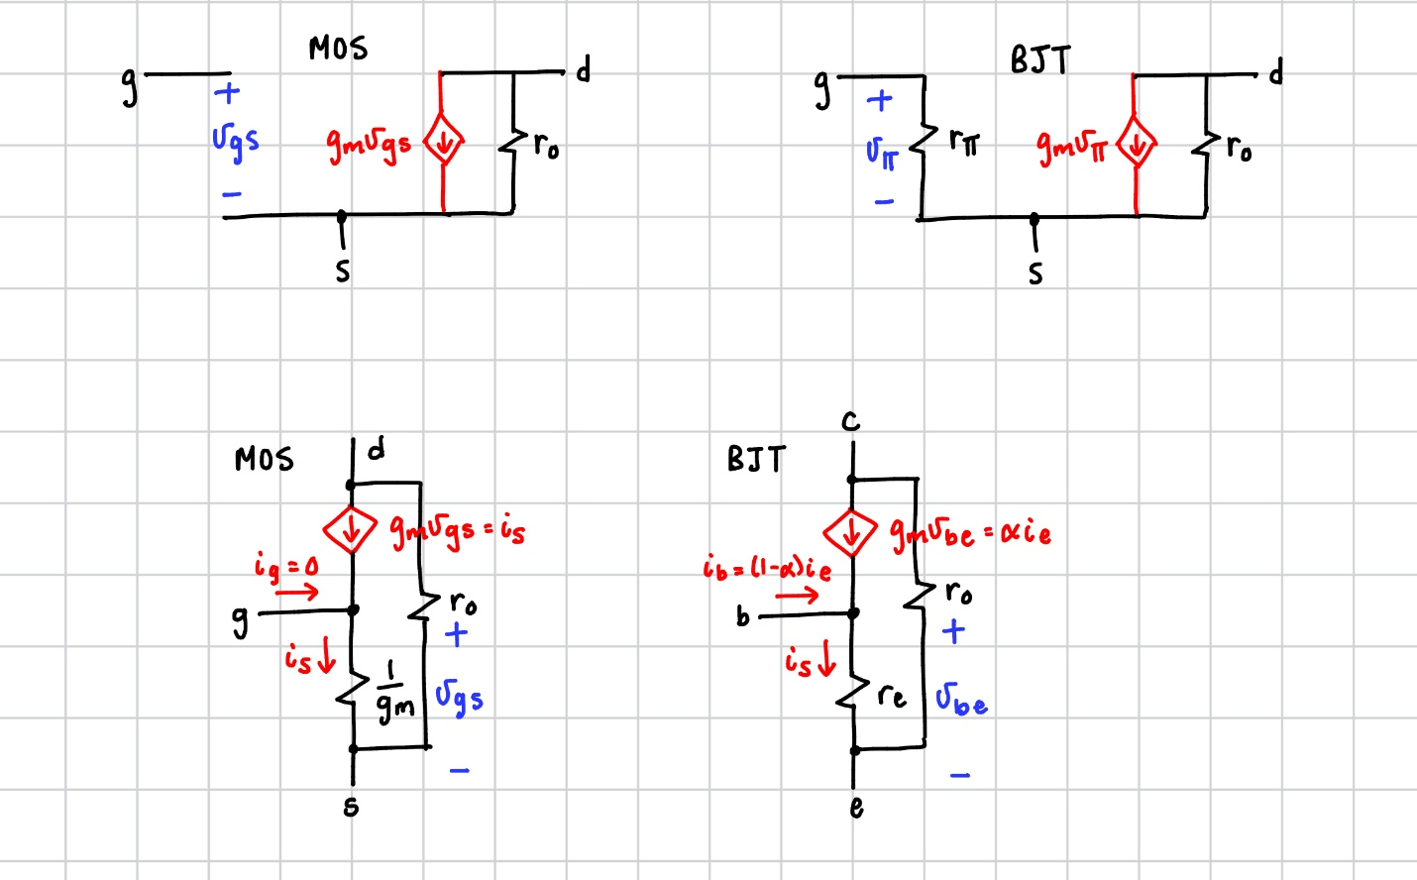

T-model
**The $π$-model is used when the s/e is AC grounded.
**The $T$-model is used when g/b is AC grounded.

MOSFET Single Stage Transistors
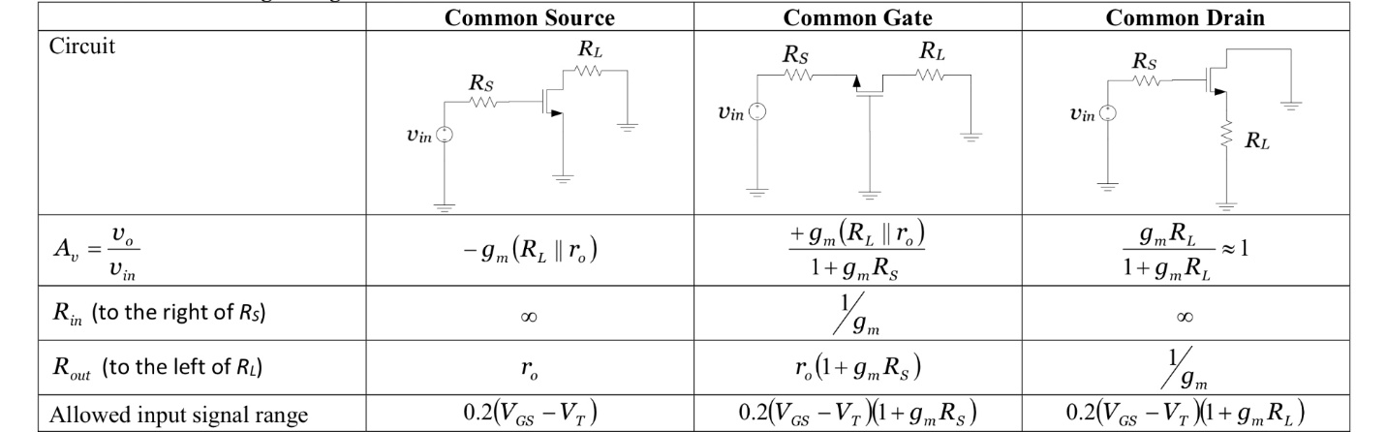

BJT Single Stage Transistors
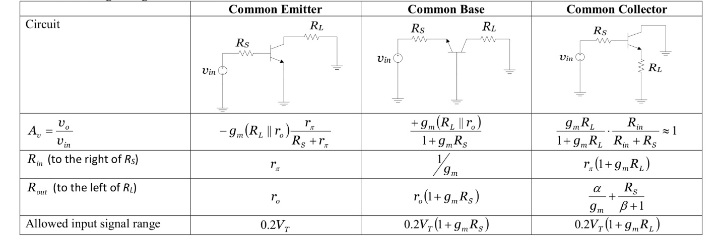

M1: Linear Two-Port Network Theory

Three Amplifier Parameters
$A_{vo}={\left.\frac{v_{o}}{v_{i}}\right|}_{R_{L}=∞}$ (open circuit voltage gain) $R_{o}=\frac{v_{x}}{i_{x}}$ (output resistance)
$R_{in}=\frac{v_{i}}{i_{i}}$ (input resistance)

Three Parameter Amplifier Model
**Used when analyzing the overall amplifier block i.e. when $R_{L}/R_{sig}$ present.

Voltage Gains of Amplifiers
$A_{v}=\frac{v_{o}}{v_{i}}$ (amplifier voltage gain including $R_{L}$)
$G_{v}=\frac{v_{o}}{v_{sig}}$ (overall voltage gain including $R_{L}$ and $R_{sig}$)

Two-Port Network Parameters:
**Used when $R_{in}$ not function of $R_{L}$ and $R_{sig}$.
Impedance (z) Parameters:  $$v_{1}=z_{11}i_{1}+z_{12}i_{2}$$  $$v_{2}=z_{21}i_{1}+z_{22}i_{2}$$ | Admittance (y) Parameters:  $$i_{1}=y_{11}v_{1}+y_{12}v_{2}$$  $$i_{2}=y_{21}v_{1}+y_{22}v_{2}$$
Hybrid (h) Parameters:  $$v_{1}=h_{11}i_{1}+h_{12}v_{2}$$  $$i_{2}=h_{21}i_{1}+h_{22}v_{2}$$ | Inverse-Hybrid (g) Parameters:  $$i_{1}=g_{11}v_{1}+g_{12}i_{2}$$  $$v_{2}=g_{21}v_{1}+g_{22}i_{2}$$

z | y | h | g
$${R_{o}=z}_{22}$$ | $$R_{o}=1/y_{22}$$ | $$R_{o}=1/h_{22}$$ | $$R_{o}=g_{22}$$
$$R_{i}=z_{11}$$ | $$R_{i}=1/y_{11}$$ | $$R_{i}=h_{11}$$ | $$R_{i}=1/g_{11}$$
$$A_{zo}=z_{21}$$ | $$A_{go}=y_{21}$$ | $$A_{io}=h_{21}$$ | $$A_{vo}=g_{21}$$
$$R_{in}=\frac{v_{i}}{i_{i}}$$ | $$Y_{in}=\frac{i_{i}}{v_{i}}$$ | $$R_{in}=\frac{v_{i}}{i_{i}}$$ | $$Y_{in}=\frac{i_{i}}{v_{i}}$$

M2: Differential Amplifiers

Definition
$ν_{DM}=ν_{G1}-ν_{G2}$ $ν_{CM}=\frac{ν_{G1}+ν_{G2}}{2}$
$ν_{G1}=ν_{CM}+\frac{ν_{DM}}{2}$ $ν_{G2}=ν_{CM}-\frac{ν_{DM}}{2}$

Differential Pair Large Signal Analysis
For MOS: $V_{DM,max}=\sqrt{2}V_{OV}$ $v_{dm,max}=\frac{V_{OV}}{2}$
For BJT: $V_{DM,max}=4V_{T}≈100 mV$ $v_{dm,max}=\frac{V_{T}}{2}≈12.5 mV$

DC Input Common Mode Range
Highest $V_{CM}$ is limited by $Q_{1,2}$ to remain in saturation: $V_{D(S)}≥V_{CM\left(GS\right)}-V_{t}$
$⇒V_{CM,max}=V_{D}-V_{t}$
Lowest $V_{CM}$ is determined by minimum voltage $V_{CS}$ across the current source $I$.
i.e. $V_{CSmin}=-V_{SS}+V_{CM,min}+V_{GS}$ (KVL)
$⇒V_{CM,min}=-V_{GS}+V_{CSmin}-V_{SS}$

Differential Pair Small Signal Analysis
$A_{d}=\frac{v_{o2}}{v_{id}} ; v_{o2}=\frac{ν_{od}}{2}$ $A_{cm}=\frac{v_{o2}}{v_{cm}}$

Half Circuit Analysis for Differential-Mode $ν_{id}$ and Common-Mode $ν_{cm}$
Differential-Mode $ν_{id}$  - Requires symmetry.  - Cut circuit in half.  - DM Inputs are equal and opposite.  - Inputs: $+\frac{ν_{id}}{2}$ (Q1), $-\frac{ν_{id}}{2}$ (Q2)  - Outputs: $-\frac{ν_{od}}{2}$ (Q1), $+\frac{ν_{od}}{2}$ (Q2)  - Source node = 0V (AC virtual ground)  - Analyze half with ss model. | Common-Mode $ν_{cm}$  - Requires symmetry.  - Cut circuit in half.  - CM Inputs are equal and in-phase.  - Inputs/outputs: $ν_{cm}$  - Source node = 2$R_{Source}$.  - Analyze half with ss model.

Common-Mode Rejection Ratio (CMRR)
$CMRR=\frac{\left|A_{d}\right|}{\left|A_{cm}\right|}$

M3: Frequency Response

Definition
Lower 3dB Frequency $f_{L}$ Upper 3dB Frequency $f_{H}$
Midband Voltage Gain $A_{M}=\frac{v_{o}}{v_{sig}}$ (short circuit all capacitors)

